Addendum: Demographic Controls and DAG-Based Interpretation of Hex-Level Correlations
Date: April 2026

1. Introduction
The base correlation report establishes strong spatial co-occurrence between homicide, other crime types, and selected infrastructure categories at the 500-meter hex level. This addendum extends that analysis by addressing a core inferential issue: ecological correlations may be confounded by neighborhood socioeconomic context.

In particular, positive homicide correlations for variables such as schools or places of worship can reflect shared geography with disadvantaged residential areas, rather than direct causal effects of those institutions. To formalize this concern, we use a directed acyclic graph (DAG) framing in which socioeconomic disadvantage acts as a common-cause block for multiple observed outcomes.

2. Data Sources
This addendum uses existing project artifacts and does not introduce new upstream raw data.

2.1 Hex-level Crime and Infrastructure Table
- data/processed/crime_infrastructure_hex_merged.csv
This table contains per-hex counts of crime types and infrastructure features generated by the correlation-analysis stage.

2.2 Hex-level Socioeconomic Fields
- data/processed/modeling/chicago_hex_modeling_table.csv
This table provides the socioeconomic fields used in this addendum:
- per_capita_income
- poverty_pct
- hardship_index
- community_area_number

2.3 Join and Sample Size
The two processed tables are merged on hex_id.
- merged hex rows: 1,778
- rows with socioeconomic fields after join: 1,524
- complete-case rows used for adjusted analysis: 1,524

3. Methodology

3.1 Conceptual DAG
We adopt the following conceptual DAG for interpretation:
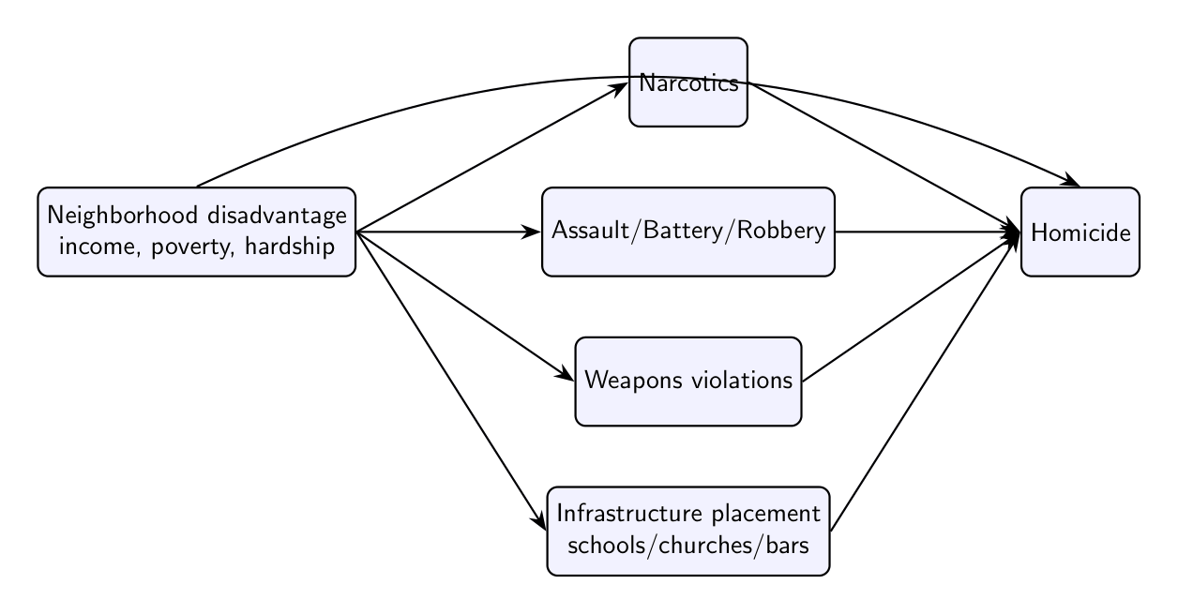
This DAG encodes the idea that observed pairwise associations with homicide may be partly attributable to shared dependence on neighborhood conditions.

3.2 Estimands
For each variable (X), we estimate:
- Naive association: Spearman
$ρ(X, Homicide)$
- Conditioned association: Partial Spearman
$ρ(X, Homicide | PerCapitaIncome, PovertyPct, HardshipIndex)$
Partial Spearman is computed using the inverse of the Spearman correlation matrix (precision-matrix approach).

3.3 Scope
This is an adjustment-based extension of descriptive spatial correlation analysis. It improves interpretation relative to unadjusted pairwise correlations, but does not by itself identify causal effects.

3.4 Label Harmonization
To avoid splitting counts across historical aliases, crime labels are harmonized before estimation. In this revision, crim_sexual_assault is merged into criminal_sexual_assault, and the alias column is removed before computing naive and partial correlations.

4. Results

4.1 Full Crime-Type Results (All Crime Variables in the Main Correlation Report)
Crime Variable | Naive Spearman | Partial Spearman (controls) | Delta
Weapons Violation | 0.889 | 0.821 | -0.069
Narcotics | 0.857 | 0.790 | -0.067
Battery | 0.856 | 0.814 | -0.042
Assault | 0.854 | 0.812 | -0.042
Offense Involving Children | 0.817 | 0.752 | -0.065
Robbery | 0.814 | 0.774 | -0.040
Interference With Public Officer | 0.813 | 0.733 | -0.080
Criminal Sexual Assault | 0.792 | 0.754 | -0.038
Other Offense | 0.800 | 0.771 | -0.030
Criminal Damage | 0.791 | 0.773 | -0.019
Arson | 0.783 | 0.712 | -0.072
Motor Vehicle Theft | 0.780 | 0.740 | -0.040
Public Peace Violation | 0.743 | 0.697 | -0.047
Gambling | 0.731 | 0.636 | -0.095
Burglary | 0.714 | 0.706 | -0.008
Criminal Trespass | 0.701 | 0.703 | +0.002
Sex Offense | 0.679 | 0.672 | -0.007
Kidnapping | 0.642 | 0.599 | -0.043
Intimidation | 0.612 | 0.590 | -0.022
Stalking | 0.592 | 0.577 | -0.014
Prostitution | 0.591 | 0.533 | -0.058
Theft | 0.581 | 0.627 | +0.046
Deceptive Practice | 0.533 | 0.625 | +0.092
Liquor Law Violation | 0.476 | 0.524 | +0.048
Concealed Carry License Violation | 0.451 | 0.348 | -0.103
Obscenity | 0.286 | 0.319 | +0.033
Human Trafficking | 0.205 | 0.131 | -0.074
Public Indecency | 0.151 | 0.170 | +0.019

The following table reports naive and demographically adjusted associations for every crime variable in the report-level merged table (excluding homicide and total_crime).

4.2 Full Infrastructure Results (All Infrastructure Variables in the Main Correlation Report)
The following table reports naive and adjusted associations for all infrastructure features and aggregates (infra_*) in the merged table.

Infrastructure Variable | Naive Spearman | Partial Spearman (controls) | Delta
Place of Worship | 0.449 | 0.408 | -0.041
Protective (Aggregate) | 0.425 | 0.424 | -0.001
Total Infrastructure | 0.388 | 0.445 | +0.057
School | 0.273 | 0.277 | +0.005
Fuel | 0.230 | 0.215 | -0.016
Playground | 0.172 | 0.165 | -0.007
Social Facility | 0.152 | 0.134 | -0.018
Community Centre | 0.130 | 0.116 | -0.014
Risk (Aggregate) | 0.108 | 0.255 | +0.147
Supermarket | 0.078 | 0.124 | +0.046
Laundry | 0.074 | 0.129 | +0.056
Clinic | 0.055 | 0.070 | +0.015
Fire Station | 0.054 | 0.076 | +0.022
Library | 0.052 | 0.067 | +0.015
Alcohol | 0.048 | 0.120 | +0.072
Park | 0.042 | 0.082 | +0.039
Arts Centre | 0.041 | 0.062 | +0.021
Casino | 0.022 | 0.051 | +0.029
Restaurant | 0.022 | 0.051 | +0.029
Police | 0.017 | 0.008 | -0.009
Nursing Home | 0.016 | -0.018 | -0.034
E-Cigarette | 0.012 | 0.059 | +0.047
Tobacco | 0.011 | 0.073 | +0.062
Nightclub | 0.005 | 0.047 | +0.042
Courthouse | 0.002 | -0.005 | -0.006
Research Institute | -0.001 | -0.017 | -0.016
Prison | -0.004 | -0.023 | -0.020
Hospital | -0.004 | 0.001 | +0.006
Pharmacy | -0.005 | 0.079 | +0.085
Monastery | -0.013 | -0.012 | +0.001
Payment Terminal | -0.026 | 0.014 | +0.040
Strip Club | -0.034 | -0.015 | +0.019
ATM | -0.038 | 0.036 | +0.073
Bar | -0.079 | 0.108 | +0.188
Pub | -0.082 | 0.039 | +0.122

4.3 Socioeconomic Variables and Homicide
- per_capita_income vs homicide: -0.524
- poverty_pct vs homicide: +0.566
- hardship_index vs homicide: +0.482
These values support the role of socioeconomic structure as a major contextual correlate of homicide concentration.

4.4 Visual Comparison: Selected Naive vs Adjusted Correlations
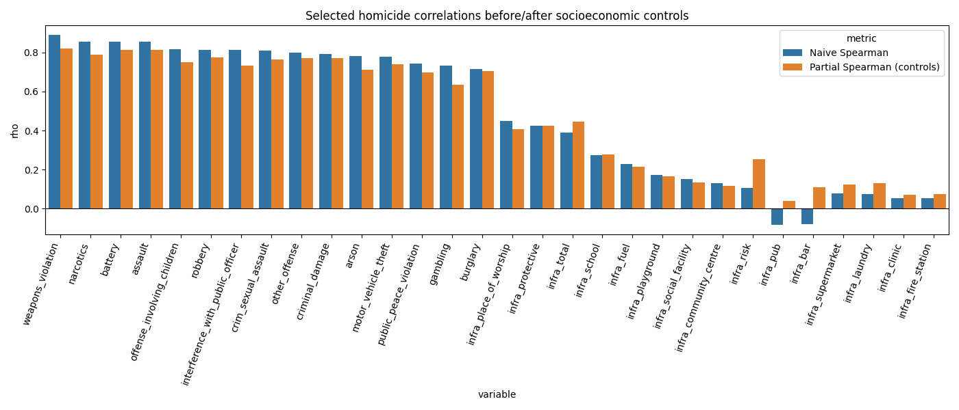
Figure 1. Selected crime and infrastructure variables comparing naive Spearman associations with demographically adjusted partial Spearman associations. Adjusted estimates condition on per-capita income, poverty percentage, and hardship index.

5. Discussion

5.1 Violent-Crime Cluster Remains Strong After Controls
Weapons violations, battery, assault, narcotics, and robbery remain the dominant homicide correlates after conditioning on income, poverty, and hardship. Several other interpersonal or enforcement-linked categories (e.g., offense involving children, interference with public officer, sexual-assault categories) also retain moderate-to-strong adjusted associations.

5.2 Infrastructure Effects Are Sensitive to Adjustment
Infrastructure variables show heterogeneous adjustment behavior. Some variables change only marginally (e.g., infra_protective, infra_school), whereas others shift substantially in magnitude and sign (e.g., infra_bar, infra_pub, infra_risk, infra_pharmacy, infra_atm). This pattern is consistent with confounding by neighborhood composition and land-use sorting across the city.

5.3 Interpretation of “Protective” Infrastructure
The positive naive association between some protective categories and homicide should be interpreted as spatial co-location, not as evidence that protective institutions increase lethal violence. In the DAG framing, these institutions are partly colocated with neighborhoods where structural disadvantage and crime burden are both elevated.

6. Limitations
- No causal identification design. Partial correlation is adjustment-based and remains observational.
- Potential residual confounding. Only three socioeconomic controls are included in this addendum.
- Cross-sectional aggregation. Temporal dynamics are not modeled in these estimates.
- Spatial dependence. Neighboring hexes are not independent, and this framework does not yet include an explicit spatial regression structure.

7. Conclusion
Adding demographic controls materially improves the interpretation of the hex-level homicide correlations. The main violent-crime correlates remain strong after adjustment, while several infrastructure relationships become more clearly understood as confounded ecological overlap rather than direct pathways.

Accordingly, this addendum recommends that project reporting distinguish between:
- spatial co-occurrence (naive correlations), and
- associations conditional on observed socioeconomic context (partial correlations).
This distinction better aligns the empirical results with defensible causal language.

8. Potential Next Steps
- Complete hex-to-community mapping for all hexes from the full crimes file.
- Count-model estimation with controls (e.g., negative binomial / Poisson with robust errors).
- Spatial lag/error modeling to address dependence across adjacent hexes.
- Panel/event-study extensions if temporal data are brought into a causal design.

